**CSE260 PROJECT REPORT**

**ELECTRONIC COMBINATIONAL LOCK SYSTEM**

**Introduction:**

In this group project of CSE260, team 3 consisting Shihab Muhtasim, Tasnia Ayesha, Namirul Islam and Sheikh Alima Mahbub, has worked on an electronic combinational lock system. Firstly, we will show the proposed model we have used in this project where we will explain the basic idea behind the circuit. Then, an experimental setup where we will demonstrate how the circuit works using a truth table and show our required components for this project To sum up, we will conclude this report with what we have learned by doing this project, it’s shortcomings and what should be the real life solution to the project.

**Proposed model:** Electronic Combinational Lock System

This project circuit was constructed in proteus. In this project 4 bits of the correct password or the correct lock key will be stored from before using Logicstate assuming the user has no access to that. Again on the other side of the inputs it will take 4 bits of user input pin. However, for this project to actually work the lock key has to be stored somewhere with very little proximity to where the user input interface is so that the person trying to bypass the lock cannot read the data from it. After taking the input it will run through the circuit and show us the desired output. To send a signal, we use two LEDs. The green LED only activates when the user input matches the password while the red LED activates when the user input does not match the password.

**Experimental setup:**

Required Components and Equipments:

1. AND gate

2. X-OR gate

3. Logicstate

4. Resistance

5. Switch

6. LED-Green

7. LED-Red

8. NOT gate

In the circuit four XOR gates, each of which is connected to one pair of logic states, compare the corresponding bits of the user input and stored pin’s binary value. Each XOR output is passed through a NOT gate which gives the XNOR output of each pair of logic states. These XNOR operations work as bit comparators and give us 1 as outputs when each pair of logic state values are equal and it gives 0 they do not match. If any of the XNOR outputs give 0, then the third AND gate also gives 0 which shows one or more bits of input that didn't match with the stored pin. On the contrary when all the XNOR outputs give 1, the third AND gate also gives 1 which means the password matched. For the pin to set enter a logicstate is used a pushbutton switch where 1 means Enter. The green LED will lighten when the pushbutton switch is ON and both the user input and stored value match bit by bit. On the other hand, The red LED lights up when the pushbutton is ON, and the two pin values are not the same. As the green LED light comes from an AND gate that takes one output from the third AND gate and the pushbutton switch input so the third and gate being 1 makes the green LED go and it being 0 reverses the output through a NOT gate and passes 1 through the And gate connected to the red LED so that lights up.

This lock circuit is not particularly advanced because four bits allow sixteen possible combinations. The red LED output should be connected to some form of siren or other alarms if used in a real application such as a home security system, so that entry of an incorrect code prevents an unauthorized person from trying another code. If not, all combinations wouldn't take much time before the right combination was identified! In this experiment, we did not show how the circuit can be converted into a true security system or lock mechanism as stored pin should be hidden from view of the "key" code that has to fit to the data entry input sets. If it is a part of a real security system, the data entry switch is placed outside the door, with the remaining security mounted behind the door and a key code switch. In this experiment, 8 input sets can be used to completely create the circuit. If the"Enter" pushbutton is not pressed, the LEDs are prevented from going on. The LEDs can only activate when this button is pressed. When the Enter switch is pressed and the third AND gate shows 1(high), which indicates that the right code has been entered. If “Enter” is hit and the third AND gate shows 0(low) , signifying that an erroneous code has been input. Some resistors have been used in this circuit to prevent the circuit from burning or getting any kind of damage due to high current flow as in real life this can be an issue. Again, if this were a true security system, it would be better to set the red LED output to some form of temporary lock system or alarm so it prevents someone from identifying the right code by testing out possibilities.

Truth table:

| Set pin  B0 B1 B2 B3 | User input  A0 A1 A3 A4 | X-NOR  D0 D1 D2 D3 | And gate1 | And gate 2 | output |
| --- | --- | --- | --- | --- | --- |
| 1011 | 0000 | 0100 | 0 | 0 | 0 |
| 1011 | 0001 | 0101 | 0 | 0 | 0 |
| 1011 | 0010 | 0110 | 0 | 0 | 0 |
| 1011 | 0011 | 0111 | 0 | 1 | 0 |
| 1011 | 0100 | 0000 | 0 | 0 | 0 |
| 1011 | 0101 | 0001 | 0 | 0 | 0 |
| 1011 | 0110 | 0010 | 0 | 0 | 0 |
| 1011 | 0111 | 0011 | 0 | 1 | 0 |
| 1011 | 1000 | 1100 | 1 | 0 | 0 |
| 1011 | 1001 | 1101 | 1 | 0 | 0 |
| 1011 | 1010 | 1110 | 1 | 0 | 0 |
| 1011 | 1011 | 1111 | 1 | 1 | 1 |
| 1011 | 1100 | 1000 | 0 | 0 | 0 |
| 1011 | 1101 | 1001 | 0 | 0 | 0 |
| 1011 | 1110 | 1010 | 0 | 0 | 0 |
| 1011 | 1111 | 1011 | 0 | 1 | 0 |

Circuit:

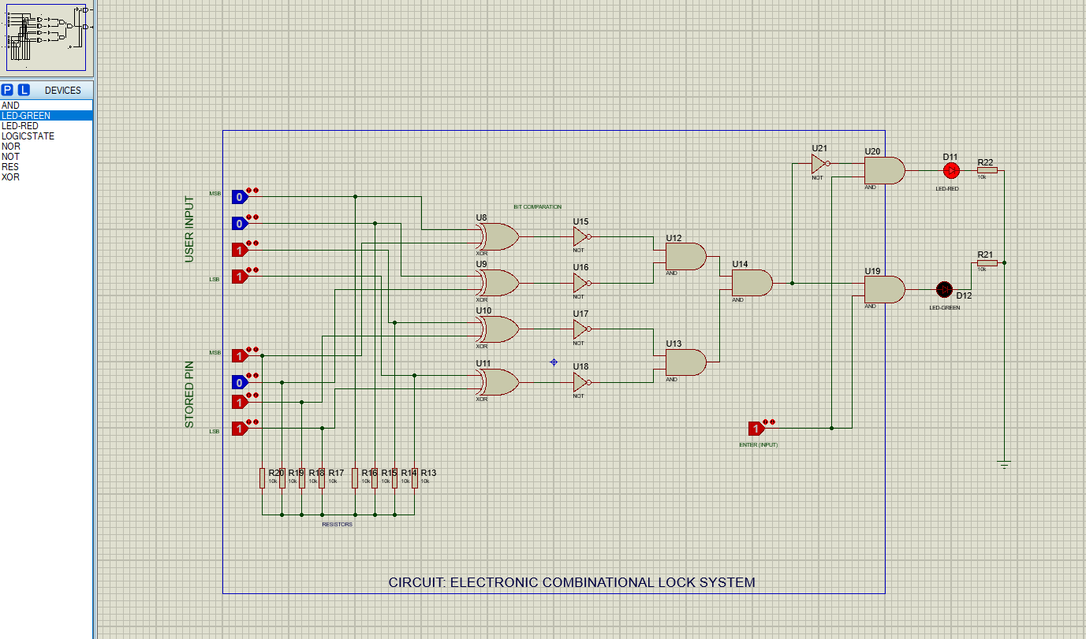

**Conclusion:**

From this experiment, we have shown how a very simple lock system works. Instead of using a key switch here, a logicstate was used. It is to be noted, though, that we have used 4-bit binary values which would result in 16 possible combinations but in reality there should me more combinations coupled with sirens, alarms, notifying a breach or even many other fail-safe attempts to close down the user to stop him from gaining access to the system. This project helped us display how to portray an electronic lock combination system which would show a green light via the LED to show the password is correct or emit a red light through another LED which would mean that the combination is actually incorrect. Not only this, but the basic knowledge of electronic combinational systems that we got through this project will help us to make more advanced and secure electronic lock systems in the future.

Project by,

Shihab Muhtasim - 21301610

Namirul Islam - 20201040

Tasnia Jannat Ayesha - 21301611

Sheikh Alima Mahbub- 20101517